Access the Database



Access Collection in Database



Insert a single document in a collection of a database

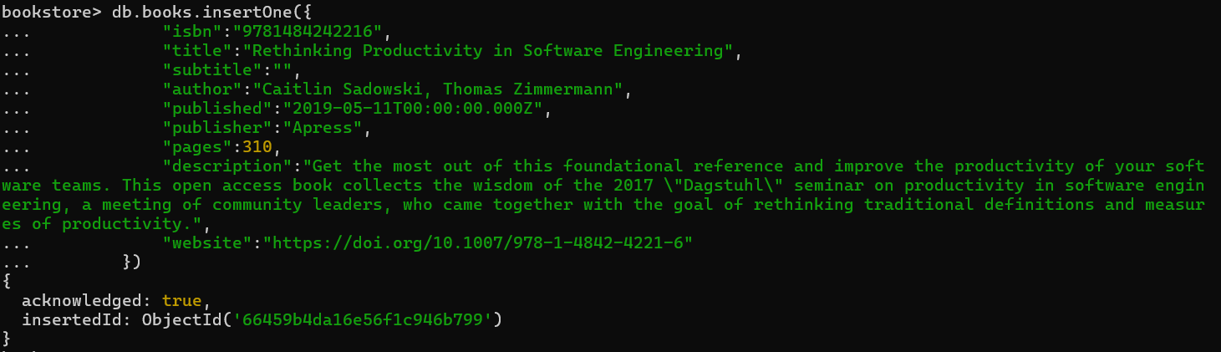

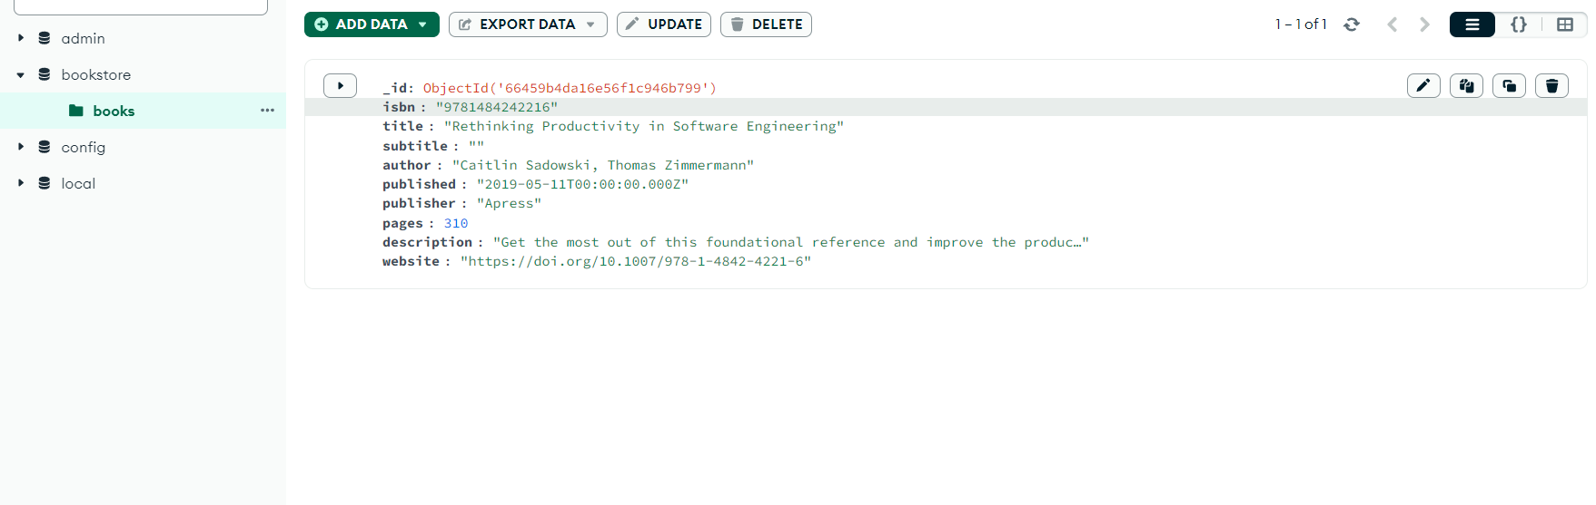

Multiple Collections in a Database

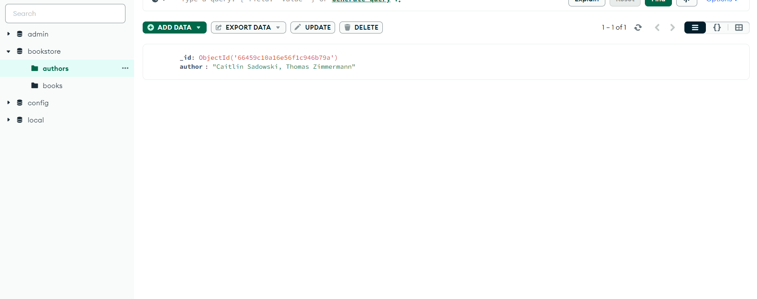

Insert multiple documents in a collection of a database

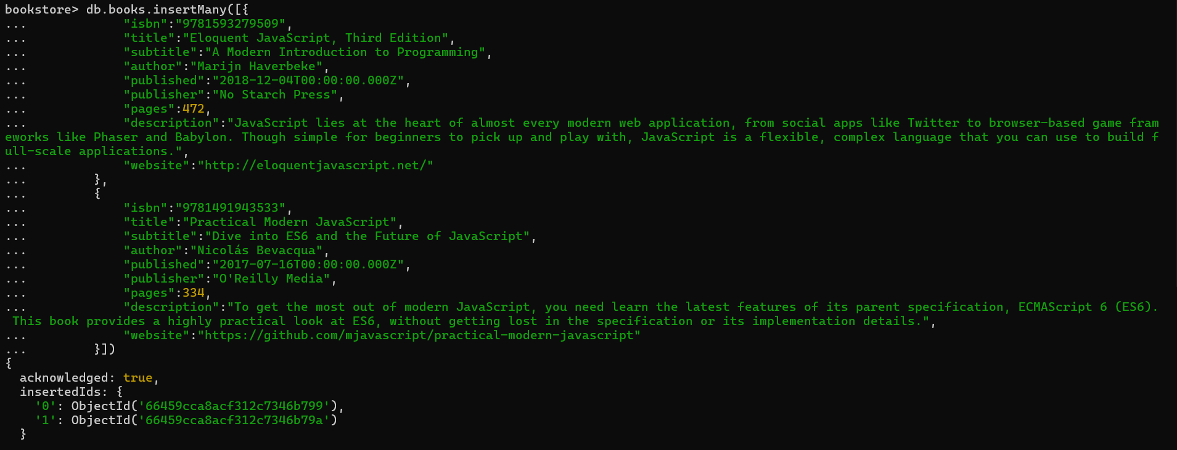

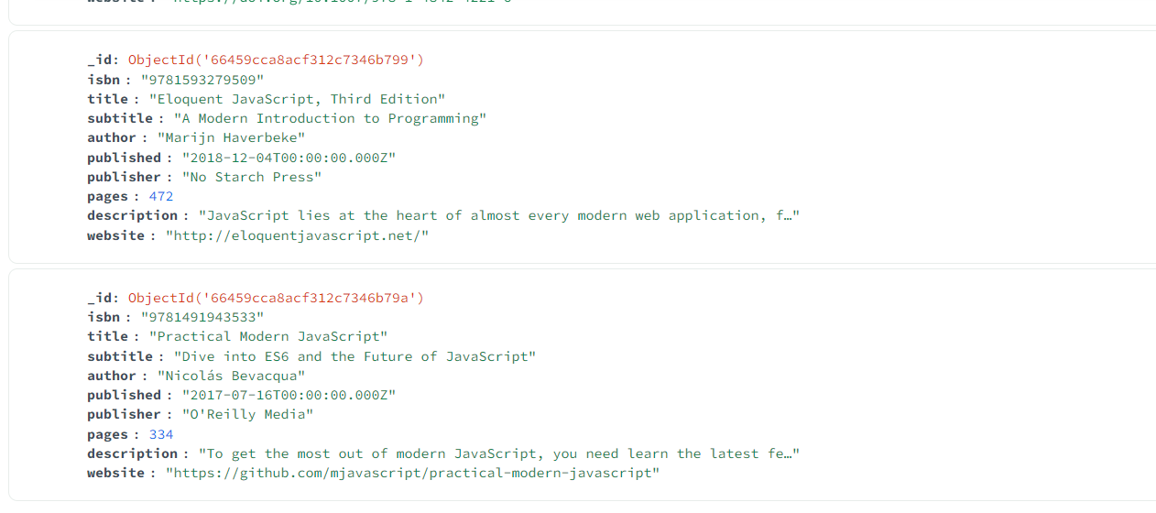

Get all the documents of a collection

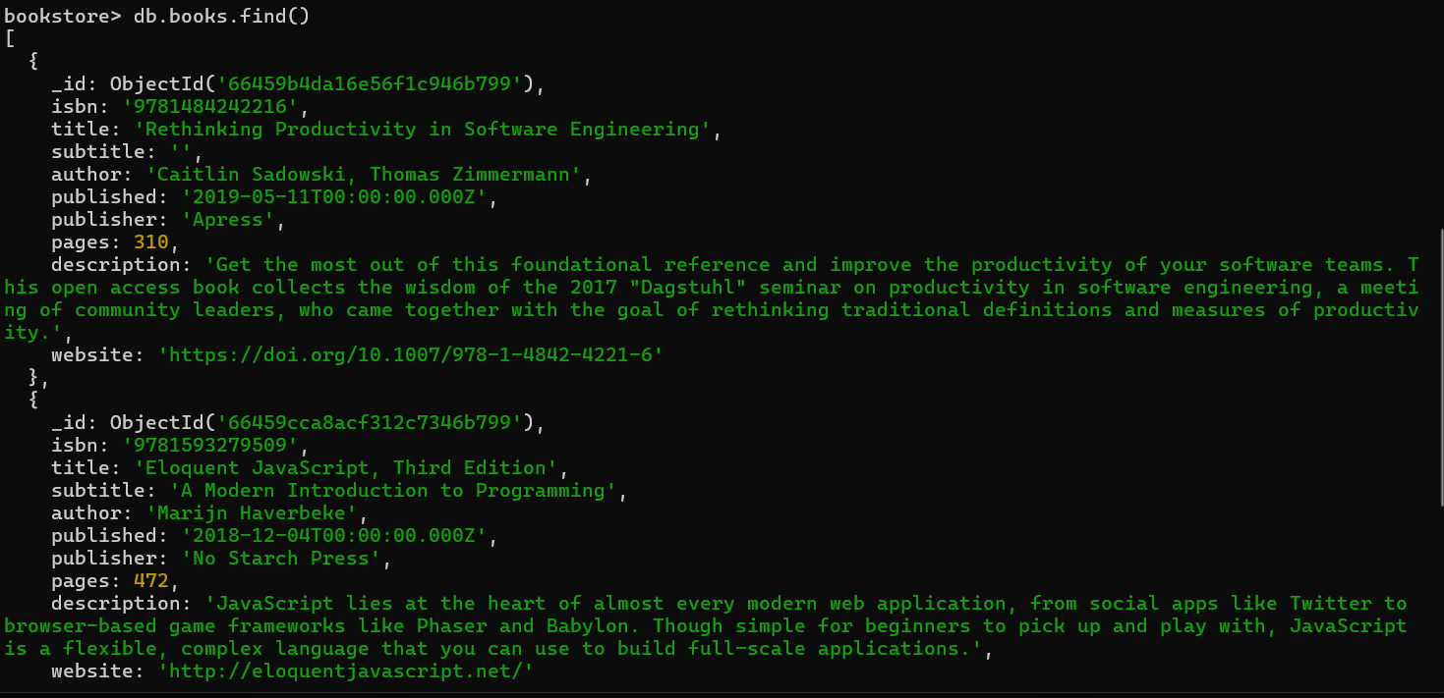

Using Filter

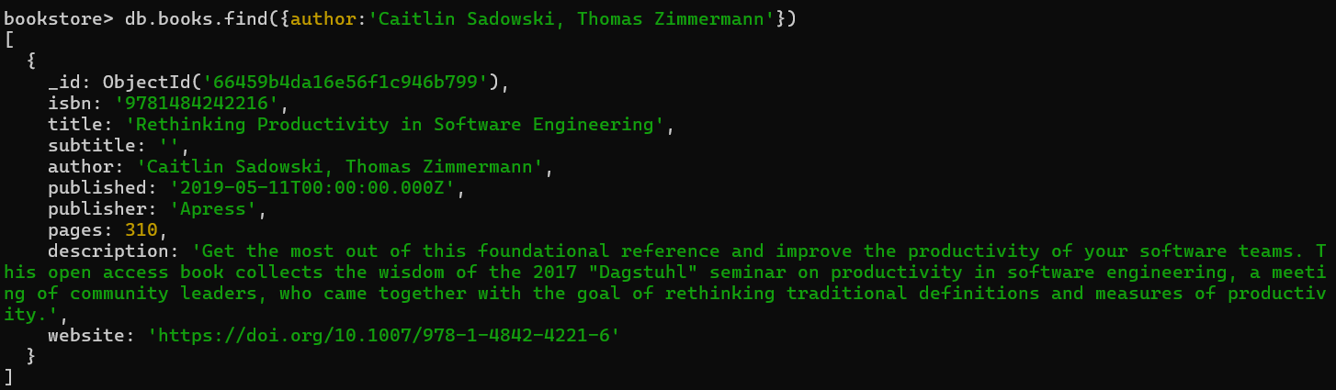

Using filter and getting particular fields

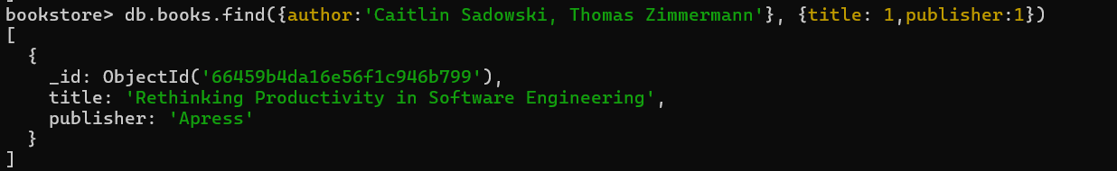

Getting particular fields without filter

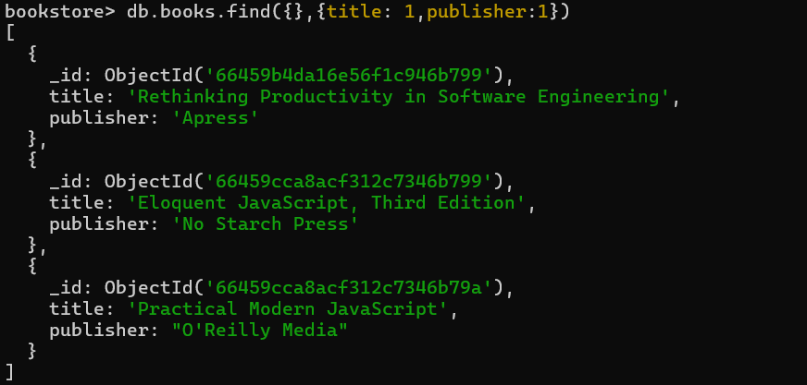

Count the total number of documents



Count the number of documents according to filter



Getting the first 2 documents from the collection

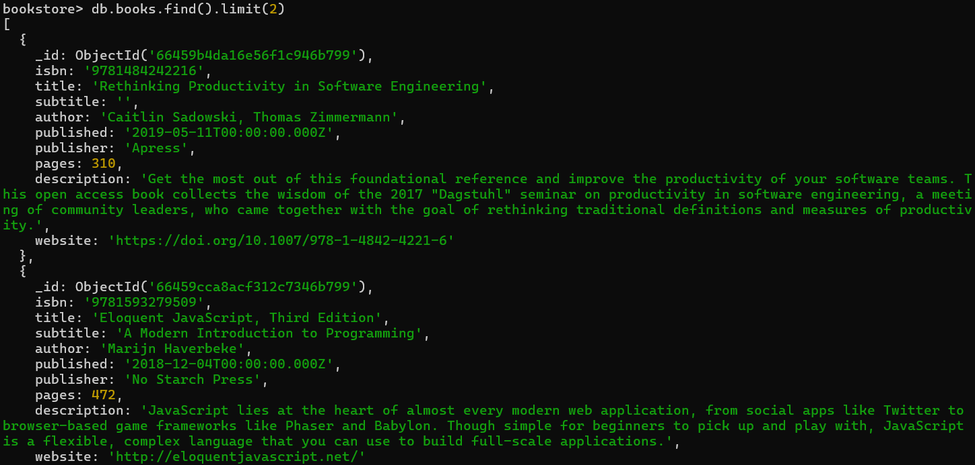

Printing all titles and sorting the documents according to the title

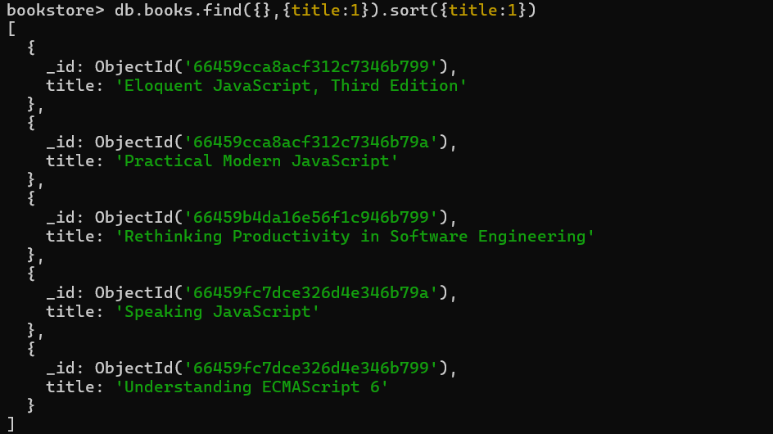

$gt operator used, to get documents with a value of pages greater than 300

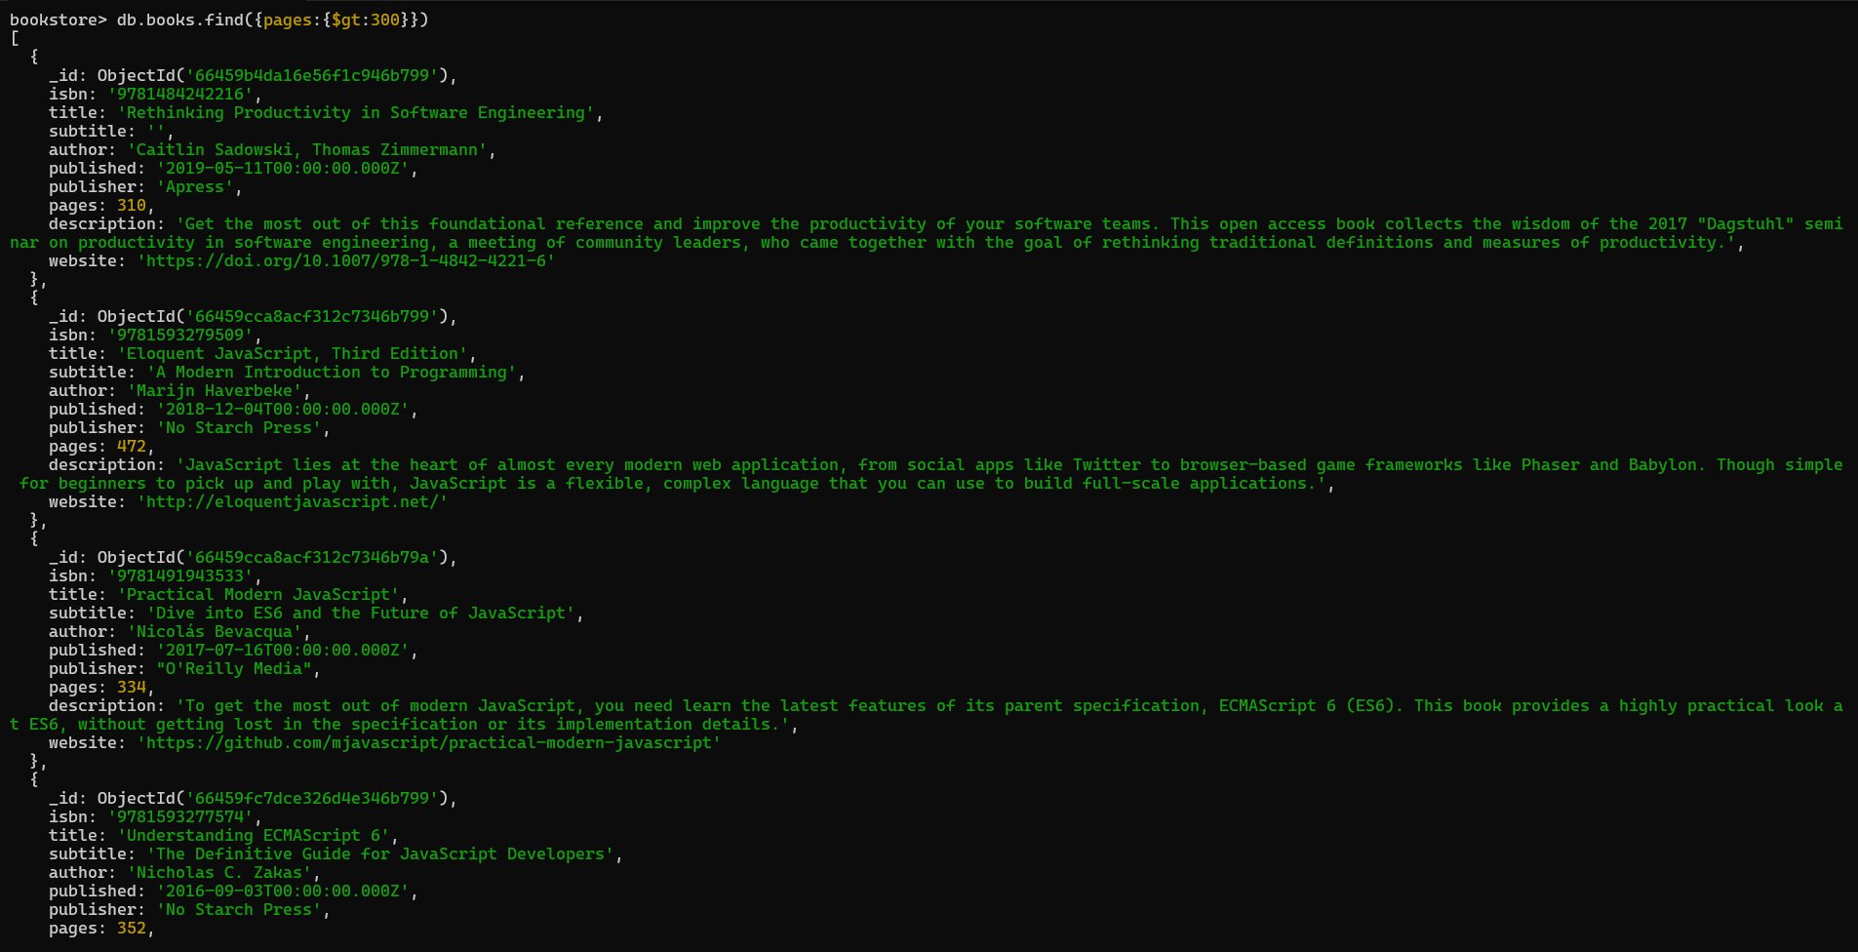

$lt operator used, to get documents with a value of pages less than 400

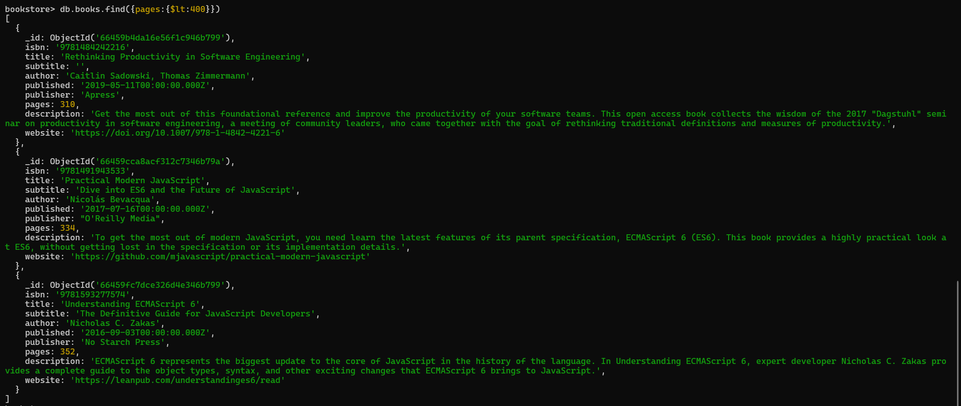

$or operator used, get documents with a value of pages greater than 300 or lesser than 200

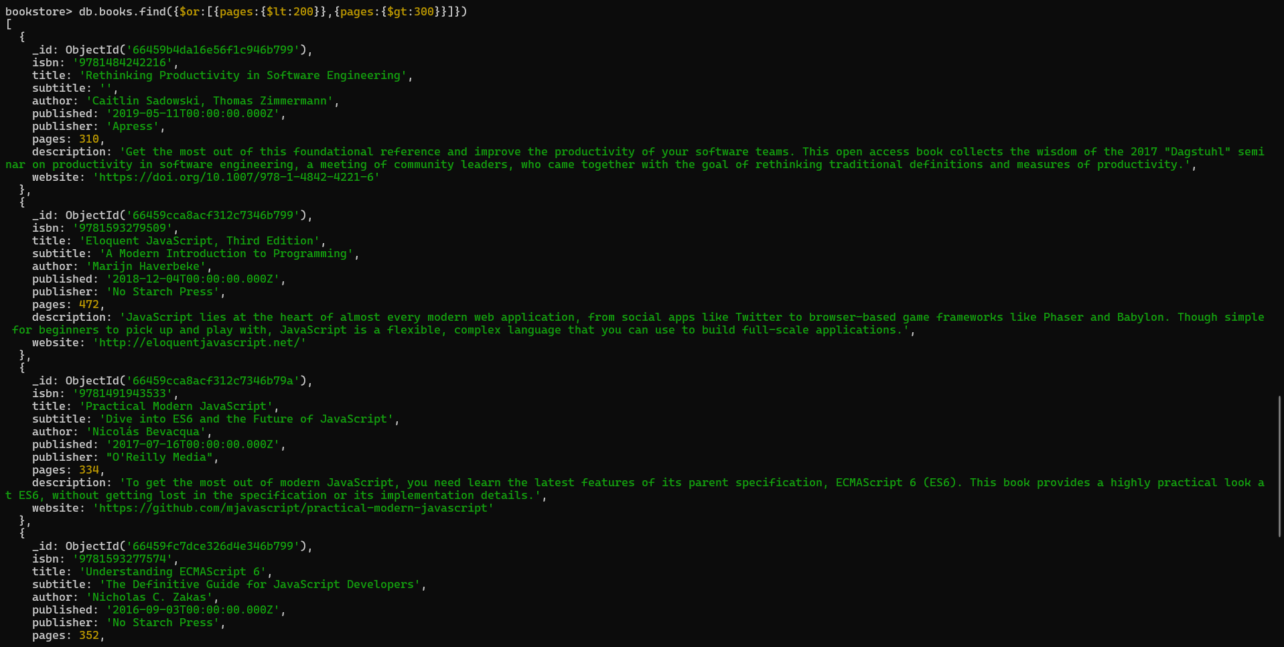

Deleting a document from the collection

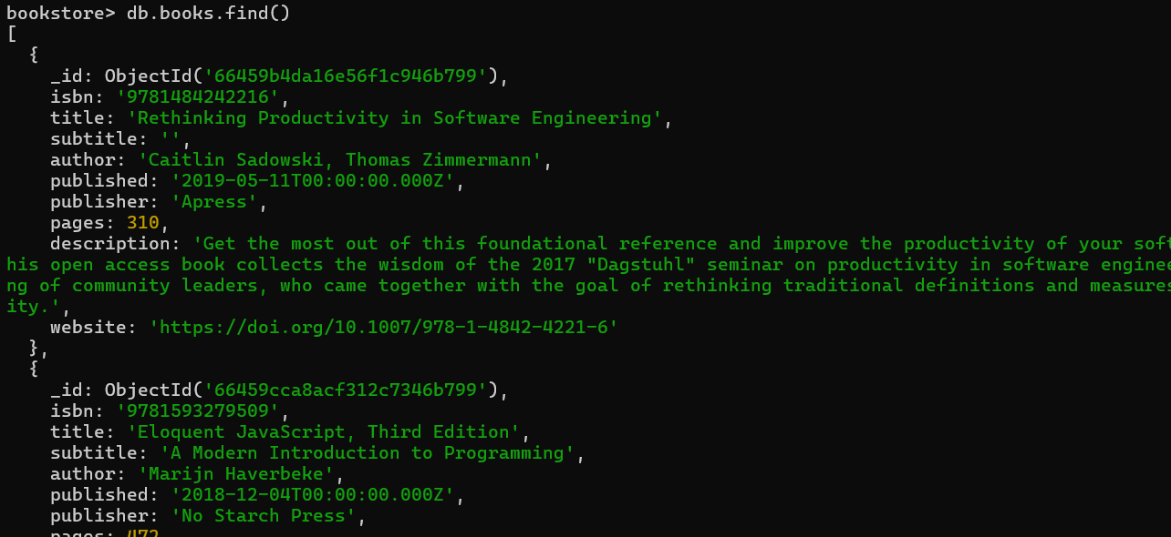

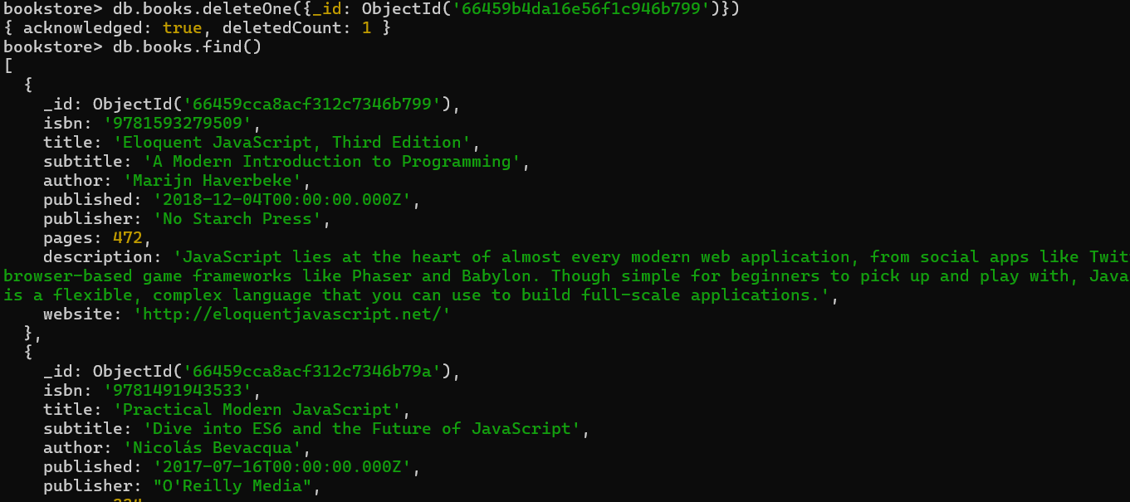

Updating document details

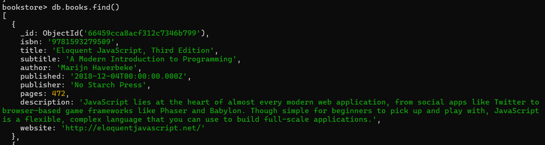

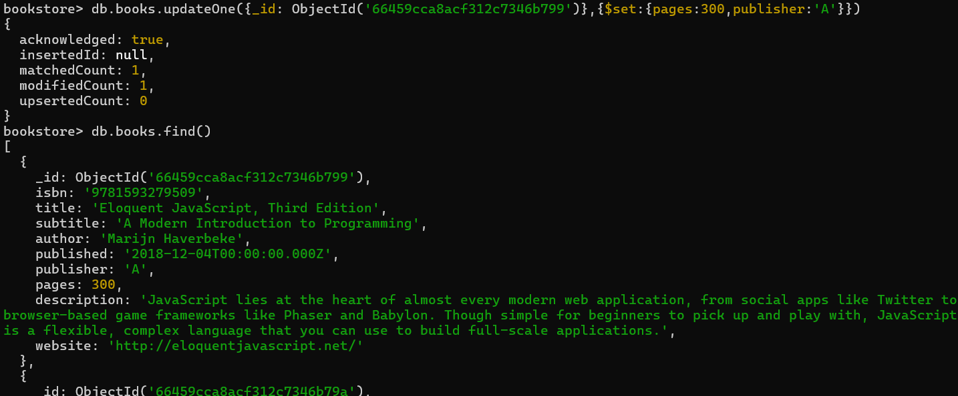

Updating document, increasing pages value by 2

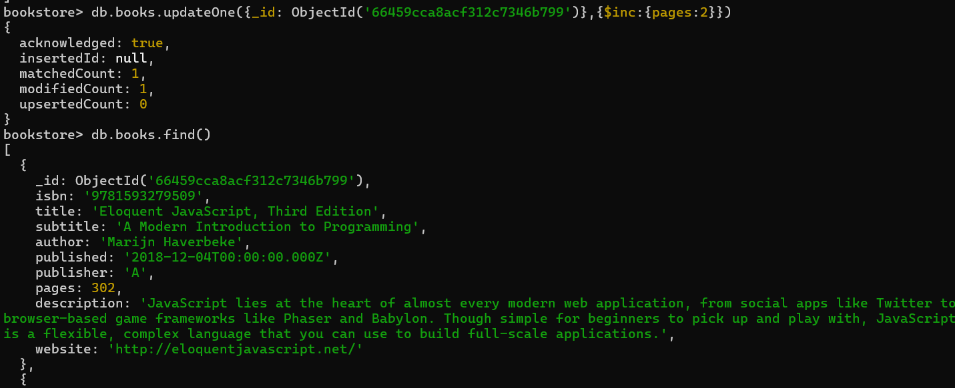

Adding field in a document

